Startups attract young people who have clear plans for the future. They want to achieve their own goals and create exactly what they dream about. When running startups, you do not need to spend a lot of money - all you need is an innovative idea, abilities and enthusiasm to work. See the examples of such startups in Kuyavian-Pomeranian region, one of the project partner of Innova Foster.

Innova Foster meeting in Torun

The last study meeting of the Innova Foster project partners took place in Torun. The main goal of the visit was the presentation about support mechanisms for startups in the region. The hosts rightly noticed that you cannot talk about startups without representatives of this environment. Therefore, young entrepreneurs who spoke about their activities were invited to the meeting.
InsBird
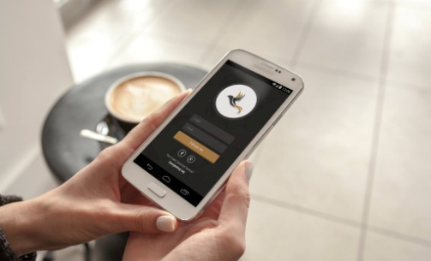

InsBird offers an innovative solution for contactless business cards that are equipped with chips. After bringing them closer to the smartphone, the data appears on the screen in the electronic version. They are fully interactive, always up to date, even after changing the data, and the user has all information on the smartphone.
In addition, companies can check the statistics and history of listed business cards, as well as transfer contacts between employees.

Representatives of InsBird say that running an innovative project is not easy as it might seem. There are many obstacles on their way. One of them is lack of the awareness of a potential client. Without the knowledge about modern technology, it is hard to imagine the possibilities and suitability of a given product. Creating the awareness is not only time-consuming, but also expensive.
However, the representatives often meet with favorable reactions. People to whom InsBird presents their product are often delighted with the way to solve the problem, are willing to test and inquire how and by what technology the product was made.

Mad4Fun
The second company that presented during the meeting was Mad4Fun. The main activity of the company is based on conceptual design, animations and 2D / 3D visual effects. The Mad4Fun team has two enthusiasts, strongly associated with Torun. They work on post-production of cinema films and TV commercials and cooperate with many famous studios from film industry.

Many people could admire the Mad4Fun team's abilities. They worked, among others in post-production shots in the film "Volta" by Juliusz Machulski, and also detonated the atomic bomb (for the first time in the Polish cinema!) in Warsaw in the film "Chain Reaction" by Jakub Paczek.

In spite of these achievements, Mad4Fun team wants to create as many projects as possible. Their dream is to create a leader similar to the TV series "Game of thrones".

Optize
Optize is a team of enthusiasts from new technologies - programmers, designers, network and system administrators. They work on the creation and development of dedicated web applications using the PHP / Symfony and Node.js / Express.js frameworks, as well as multi-platform mobile applications in Cordova technology. In addition, they create websites and online stores for companies and institutions. It is accompanied by all services related to network design and administration, as well as configuration, security and supervision of the work of webapplication systems. The Optize team believes that the success of fruitful cooperation depends on a good understanding of the client's business model and attach great importance to it at every stage of work.

Optize is a perfect example of how business can develop in a short time. The startup was founded in June 2016 by three partners who due to the amount of work, after six months began to outsource smaller projects to partner subcontractors. After 12 months of running company they searching people for the team. Currently there are 11 people in the team - 8 on the spot, 2 people on an incomplete and flexible time basis and one person remotely.

Initially, Optize was involved in the implementation of projects at CMS Bolt, eCommerce PrestaShop and custom apps in PHP or Symfony framework. In the course of its activity, the team expanded its offer by dedicated web applications in Node.js / Express.js, mobile applications in Cordova, dedicated sales pages using Angular.js and dedicated scripts that automate work or synchronize data. It also deals with the development of large inherited applications written in PHP, and it happens that in case of emergency they work with Joomla CMSs! and WordPress. The administration of Linux servers has been extended by the administration of Windows servers, networks, scripts that automate backups, performance tests and server security.

As they emphasize - one of the most positive things for their development was the location in Exea Smart Space - a business incubator in Torun where they cooperate with others in case of many project.

