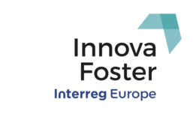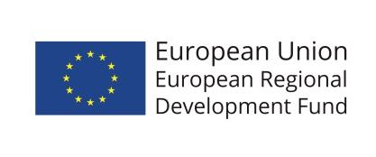

Innova Foster Consortium
Exchange Visit
Cork | Ireland
November 27th – 29th 2017

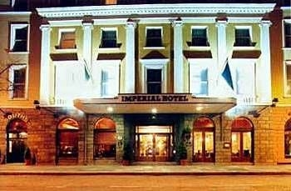
Cork City welcomed the Innova Fosters project partners to Cork to partake in the exchange meeting to review the innovation ecosystem in Cork and exchange practices, both good and bad, with partner regions and cities. Cork is the second city of the Republic of Ireland with a population of approximately 250,000 and has the highest economic productivity in the country. The group were staying at the Imperial Hotel, one of the oldest in the heart of the city.

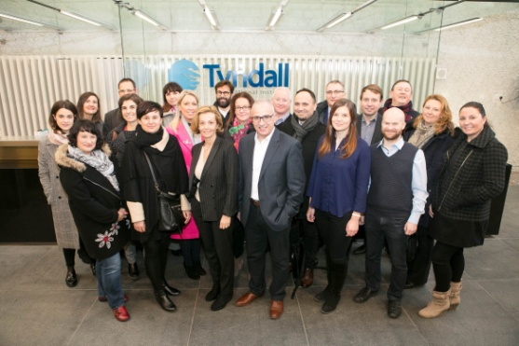
On the first day the group travelled to the Tyndall National Institute, which is a high end research and development with a global reputation in the areas of ICT nanotechnologies and photonics. The programme managers gave an overview of some of the excellent research which is undertaken there, which is supported by funding from Science Foundation Ireland and Industry and which is then commercialised and spun out to create economic impact.

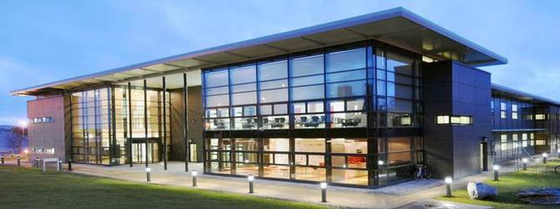
The group then travelled to Cork Institute of Technology (CIT) in the western suburbs of the City and plenary sessions were held in the Nimbus Centre located on the CIT Campus and is Ireland’s Leading Research Centre in Cyber-Physical Systems & Internet of Things.

Presentations from the local stakeholders were made giving and overview of the various programmes and supports to innovation, entrepreneurship and start-ups. These include:
- Southern Regional Assembly and the ERDF Operational programme
- Local Enterprise Office and Enterprise Ireland
- Innovation Vouchers and their application
- Perspectives of CIT –inducing Rubicon incubator, Female entrepreneurship, Student entrepreneurship and Nimbus Tec Gateway.
- Overview of Cork Innovates – local Stakeholder Partnership
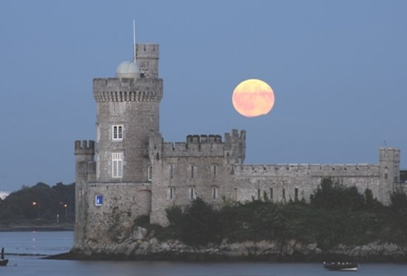
There followed a visit to Blackrock Castle Observatory, where there was a tour and heritage guide of the historic castle which was followed by a wonderful meal in the restaurant located there. The current castle dates from 1850s and has variously served as a residence, and also as a restaurant and nightclub in more recent times. In 2007 it was restored following a period of vacancy by Cork City Council and the leased to CIT who put an space observatory into it along with a space astronomy visitor experience and restaurant.
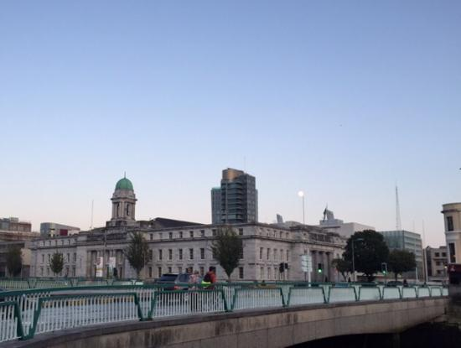
On day two of the visit the group remained in the City Centre and visited the new coworking space in City Hall. Presentations and overviews were made by:
- Cork City Council – Ecosystem support
- University College Cork – entrepreneurship programmes in Gateway incubator space: Ignite, Sprint and Blackstone Launchpad
- Cork County Council – ecosystem support
- CorkBIC -who provide mentoring and financial support to entrepreneurs locally, regionally and internationnly and who are undertaking a new international security accelerator programme based in the new space in City Hall.
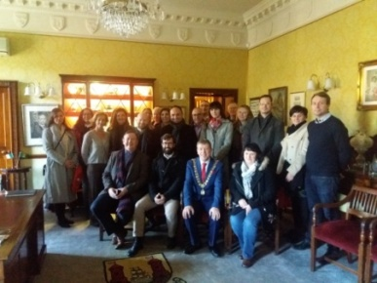
This was followed by a courtesy call to the Lord Mayor of Cork in his offices in City Hall who greeted all the attendees and spoke about Cork as an innovative and smart city and the economic growth which is currently giving rise to signicant new developments based I the ity centre.
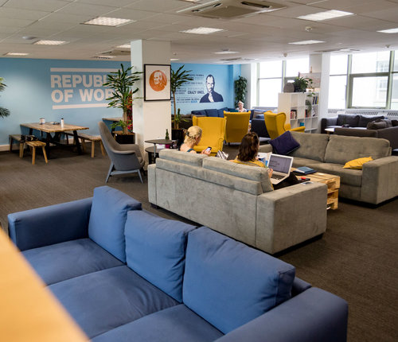

Later in the morning the group relocated a short distance to the Republic of Work, a private coworking space in the city centre. Here the group were given presentations on the Republic of Work as a space and service provider to established corporations along with start-ups in the region. This was followed by a presentation by Rebelbio, a biotech accelerator programme operated internationally by SOSV. The session conclude with a discussion and workshop on the Cork innovation ecosystem and practices which could be adopted or improved. This completed the Exchange visit.
We would like to say thanks to Aurelio who has led us well up to now, but who is now moving on to another job and we wish him well in his new role.

