Slovenia, Podravje – best practices

  - PODIM

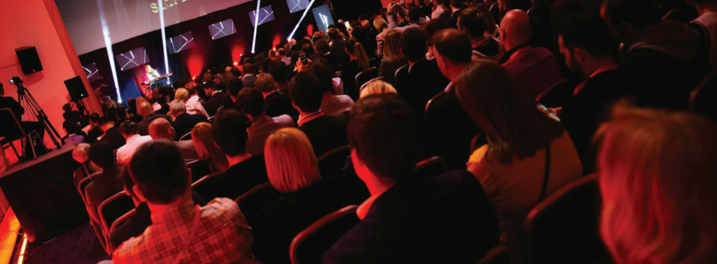

PODIM is the largest and leading conference on entrepreneurship, startups and innovation in the Alps-Adriatic region. Every year, it offers two days of intensive courses and networking opportunities. The innovativeness and speed of successful startups interfere with all aspects of the private and business life. Sometimes they entirely turn around the way a society, including industries, functions.

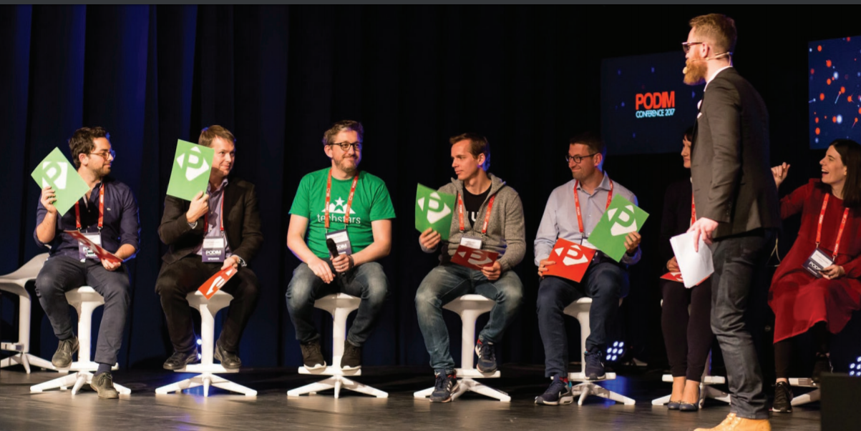

In 2017, 826 people from 33 countries attended PODIM. Structure of attendees:
- 425 startups and SMEs (51%)
- 126 regional startup ecosystem representatives (15%)
- 106 corporation representatives (13%)
- 68 investors from Europe and US (8%)
- 45 government representatives (5%)
- 30 students and academics (4%)
- 26 media representatives (3%)

Each year, the PODIM conference is where a ceremoniously announcement of the winner of the national competition Start:up of the year is made.

  - Tkalka/Weawer

Tkalka/Weaver was awarded as best coworking space in Slovenia in 2015.

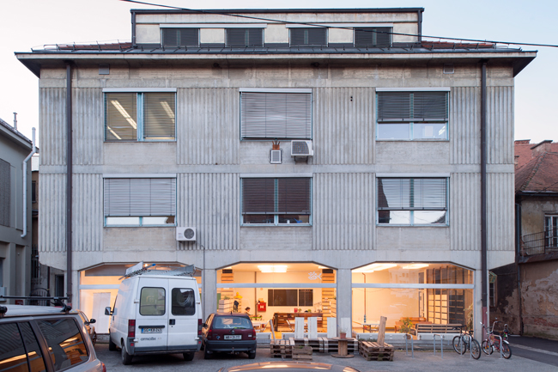

Tkalka/Weaver as alternative office building in the very heart of Maribor has reopened its gates in 2014 to a picturesque collage of organisations, initiatives and individuals who inhabit its premises in diverse processes of cooperation and in multifarious aspects of co-working. Fundamentally diverse activities of over 100 individuals and of more than 25 organisations inhabiting Tkalka/Weaver thus intertwine, connect and intersect in the organic atmosphere of a working and living habitat. Tkalka/Weaver thus stands for both the edifice it designates and the process it embodies: it is co-working in ceaseless formation; it is a delicate fabric of professional, conceptual and existential variety; it is supportive environment for socially engaged work and life.
As incubator of change on the total surface of 2500 m², Tkalka/Weaver resonates in the polyphony of entrepreneurship and social economy, tourism, sustainable development, non-governmental sector, consultancy services and advocacy, environmental programmes, intergenerational initiatives, human resources development and employment strategies, local environment and its products.

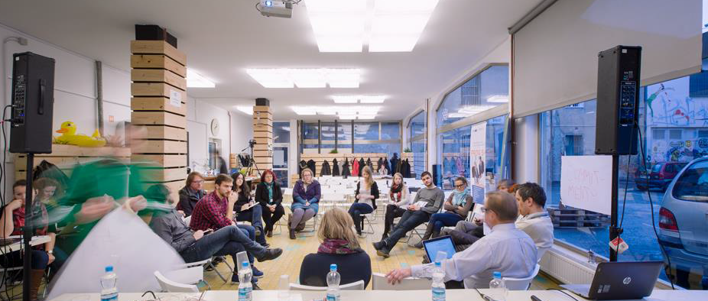

Tkalka/Weaver is a space and at the same time is a social process promoting new ways of collaboration in society and development of new social practices.

