Local startup ecosystem diagnosis – Podravje, Slovenia

November 2017

Contents

A METHODOLOGICAL APPROACH 4
B RESULTS 6
1 Startup ecosystem 6
1.1 Density and Culture 7
1.2 Funding 14
1.3 Regulatory environment 16
1.4 Support services and business training 21
2 Institutional support 21
2.1 Talent 21
2.2 Financing 25
2.3 Integrated public/private programmes, support services and business training 29
2.4 Demand-oriented support& market creation: Public procurement and other 33
3 Enhancing corporate innovation 35
4 SWOT 36
C CONCLUSIONS 37
D Annex: List of involved stakeholders 39
E References 41

The list of figures

Figure 1: Statistics for region Podravje in Slovenia. 4
Figure 2: The performance of entreprenership ecosystem in Slovenia - GEM 2016 (Rebernik et. al., 2016). 7
Figure 3: Attitudes toward entrepreneurship in Slovenia (Rebernik, M. et. al., 2016). 8
Figure 4: Entrepreneurial demography in Slovenia in 2016 (Rebernik, M. et. al., 2016). 9
Figure 5: The best startups from Slovenia (Špetič, 2017). 10
Figure 6: Assesment of density and startup culture in Podravje. 11
Figure 7: The distribution of Geek Houses offering coworking rooms and individual offices in Slovenia. 11
Figure 8: Tkalka/Weawer in Maribor, a social innovation cooperative. 13
Figure 9: Startup movement is constantly present in Slovenian media. 14
Figure 10: Assesment of the funding instruments in Podravje. 16
Figure 11: Ease of doing bussines in Slovenia (World Bank, 2017). 17
Figure 12: Services for startups at VEM offices free of charge. 19
Figure 13: National patent applications. 19
Figure 14: Assesment of the regulatory environment in Slovenia, also valid for Podravje. 21
Figure 15: Assesment of the support services and training for startups in Podravje, Slovenia. 21
Figure 16: Public and private innovators collaborate quite frequently in Slovenia (OECD, 2017a). 24
Figure 17: Assesment of the talent in Slovenia, also valid for Podravje. 25
Figure 18: Public and private financing of startups in Slovenia. 25
Figure 19: Investments in Slovenian startups – data gathered by Silicon Gardens Fund. 27
Figure 20: Characteristics of the investments in Slovenian startups in 2016 – data gathered by Silicon Gardens Fund. 28
Figure 21: Assesment of the institutional financing in Slovenia, also valid for Podravje. 28
Figure 22: Initiative Start:up Slovenia facilitates the Slovenian startup ecosystem. 31
Figure 23: Support services and business training for Slovenian startups. 31
Figure 24: The results of Initiative Start:up Slovenia. 32
Figure 25: Assesment of the institutional support services, business training and integrated public/private programmes for startups in Slovenia, also valid for Podravje. 33
Figure 26: Public procurement in Slovenia (. 34
Figure 27: A large share of public procurement in 2016 in Slovenia was not subject to competitive tendering (OECD, 2017b). 34
Figure 28: Assessment of public procurement and other demand-oriented support for startups in Slovenia, also valid for Podravje. 35
Figure 29: Assessment of enchancing corporate innovation in Slovenia, also valid for Podravje. 35

The list of tables

Table 1: Short-term entrepreneurship education initiatives in Slovenia 30
Table 2: Support environment for social entrepreneurship in Podravje. 32
Table 3: Distribution of social enterprises and social entrepreneurship support organizations in Slovenia - by regions. 33

METHODOLOGICAL APPROACH

The partners of the project Innova Foster defined that the aim of every local diagnosis at Innova Foster is to identify strengths and weaknesses at national, regional or local level. PP4 Scientific research centre Bistra Ptuj (Bistra) is focused on Podravje region, which is one of 12 statistical regions in Slovenia, located in less developed cohesion region of East Slovenia.

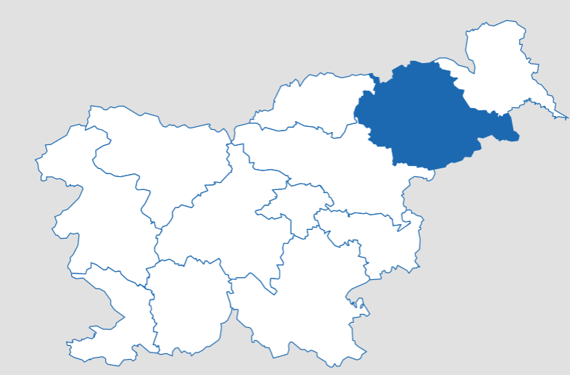 | 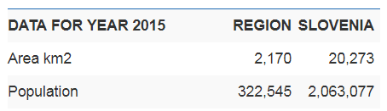  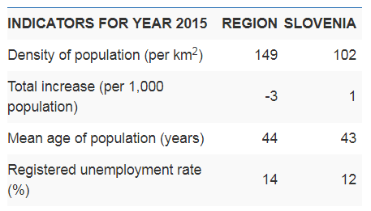

Figure 1: Statistics for region Podravje in Slovenia.

Slovenia is a Central European country, bordering on Austria (to the north), Italy (to the west), Hungary (to the north-east) and Croatia (to the east and south). It has a surface area of 20 273 km2 and a population of 2 063 077 in 2015.

The country is divided into two cohesion regions. The East Slovenia cohesion region comprises eight statistical regions: Pomurska, Primorsko-notranjska, Podravska, Posavska, Zasavska, Koroška, Savinjska and South-East Slovenia, while the West Slovenia cohesion region comprises four statistical regions: Central Slovenia, Gorenjska, Goriška and Obalno-kraška. They differ from each other in terms of geographical characteristics and level of economic development. The regions in the western part of the country are the most developed and mainly service-oriented, while the eastern part of the country is less developed, more sparsely populated and more directed towards farming and industrial activity.

The statistical office of Republic Slovenia published that 16% of Slovenia’s population lived in the Podravska statistical region in 2015. The region generated 13% of the national GDP, but GDP per capita was the fifth lowest in the country. The region had slightly less than 26,000 enterprises with on average 4.6 persons employed.

In this diagnosis of Podravje, Slovenia three topics are tacked, i.e. Startup ecosystem, Institutional support and Enhancing corporate innovation. A standard analysis matrix, formulated by project partners of Innova Foster is used to involve the stakeholders of startup ecosystem in Podravje. The local diagnosis has been done based on desktop research and discussions with the regional stakeholders. The list of involved stakeholders is in the annex. First we send e-mails to our stakeholders, but we received only 2 replies with one partially fulfilled matrix.

In the second phase we organized meetings with stakeholders, where we discussed the local diagnosis. Even more stakeholders were interviewed by phone.

Although the focus of the diagnosis is on Podravje region, many characteristics are valid for the whole Slovenia and some are controlled by the state. In the framework of the project Innova Foster, we’re considering startups as innovation-driven enterprises (IDE), which are flexible and mobile in nature. Slovenian startups are worldwide oriented and the local environment is not so important.

The following chapter gives the summary of the results of the research and discussions with the stakeholders. There are some deviations among their opinions which are mostly influenced by their narrow scope of work. In these cases the desktop research was intensified and the final mark in the analysis matrix was made by the project team of Bistra.

Afterwards, the draft of ecosystem analysis and diagnosis was a subject of peer review discussions with Innova Foster project partners and stakeholders.

RESULTS

Startup ecosystem

As the largest longitudinal study of entrepreneurship in the world, which was first carried out in 1999 (in 2002 in Slovenia), the Global Entrepreneurship Monitor (GEM) addresses the interconnectedness of entrepreneurship and economic development.

Entrepreneurial activity in Slovenia is strongly influenced by the entrepreneurship ecosystem which contributes to the introduction and functioning of innovation systems, knowledge economy, and competitiveness. In GEM the entrepreneurship ecosystem in Slovenia is assessed by gathering opinions from selected national experts (i.e., entrepreneurs and other professionals in economics, politics, state administration, and academics) with the knowledge of and professional experience in different fields affecting the development of entrepreneurship in the country. The experts were asked to assess the Slovenian entrepreneurship ecosystem based on nine entrepreneurial framework condition (EFC) categories: entrepreneurial finance, government policies, government entrepreneurship programmes, entrepreneurship education and training, R&D transfer, access to commercial and legal infrastructure, internal market dynamics and burdens or entry regulations, access to physical infrastructure, and cultural and social norms.

In 2016, most of these entrepreneurial framework conditions were still rated below the EU average, with the exception of internal market dynamics and the access to physical infrastructure as well as (to a lesser degree) government support policies (Figure 2).
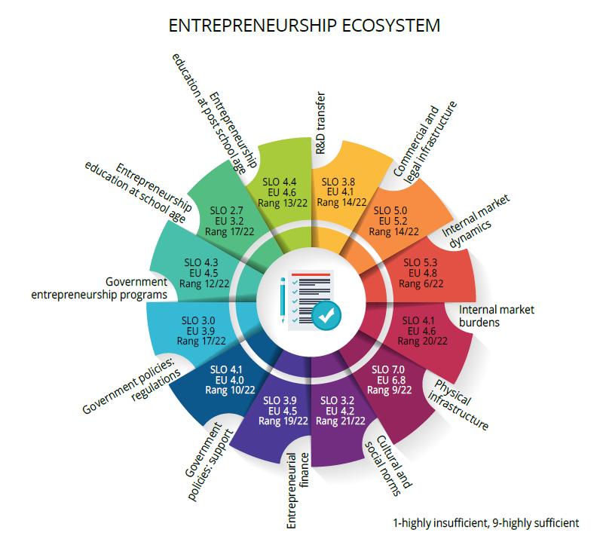
Figure 2: The performance of entreprenership ecosystem in Slovenia - GEM 2016 (Rebernik et. al., 2016).

In 2015, a research study of Slovenian startup ecosystem was performed by Rus (2015). The analysis of Slovenian startup companies and the startup ecosystem, was carried out at the end of 2015 as part of the Slovenian Entrepreneurship Observatory, and included 156 participating startup companies.

Density and Culture

According to the GEM 2016 successful entrepreneurs are highly respected in Slovenia as almost 70% of the Slovenian adult population believe that successful entrepreneurs have a high status in the Slovenian society (Rebernik, M. et al., 2016). In the group of European countries, this ranks Slovenia 12th, with Ireland being at the top with almost 85%.
Although Slovenians hold successful entrepreneurs in high regard, their belief that entrepreneurship is a good career choice is much lower. Globally, two-thirds of the adult population in the efficiency-driven economies see entrepreneurship as a good career choice, whereas only around 60% of the population in the factor- and innovation driven economies believe so (ibid).
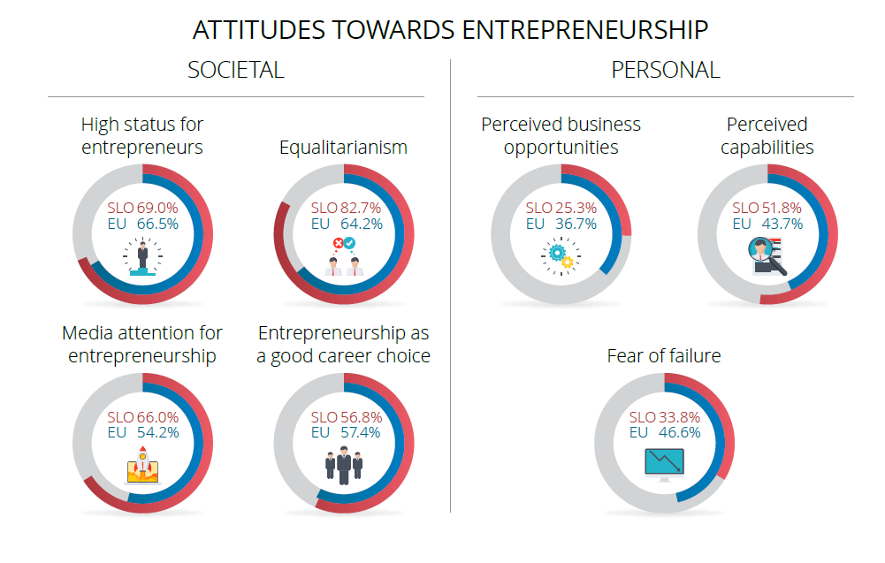
Figure 3: Attitudes toward entrepreneurship in Slovenia (Rebernik, M. et. al., 2016).

One of the quite deeply rooted Slovenian social norms is the belief that most people in Slovenia would prefer that everyone had a similar standard of living.

The perception of business opportunities is one of the core components of entrepreneurship; without it, entrepreneurship is not possible. In 2013, a modest 16% of the Slovenian population believed that good business opportunities existed in the areas in which they lived; this percentage increased to 17.3% in 2014 and 20.5% in 2015. In 2016, this percentage increased slightly, too, as the average of 25.3% of people perceived good opportunities for starting a new business. Nevertheless, this percentage still ranks Slovenia at the bottom end of the global scale: 59th place among the 65 participating economies.

In 2016 Slovenia finally recorded an increased interest in entrepreneurial activity. The proportion of the adult population who intend to start a business in the next three years increased substantially to 14.3%.

The perception of entrepreneurial capabilities and competences shows not only the knowledge and skills of individuals, but also their belief in having the capacities to establish a business. In Slovenia, on average, 51.8% of the adult population trusts in their entrepreneurial capabilities and competences, this ranks Slovenia high in 5th place among the European countries. Unfortunately, this (self-perceived) entrepreneurial potential is not realized, especially in those areas and with such companies that would result in economic growth and new job creation.

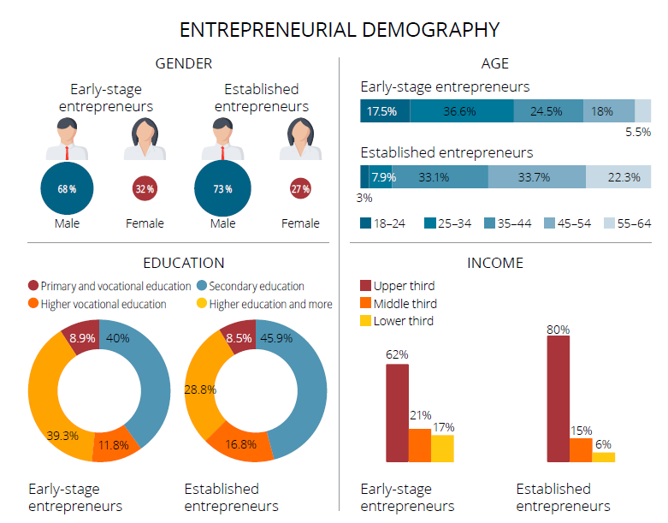
Figure 4: Entrepreneurial demography in Slovenia in 2016 (Rebernik, M. et. al., 2016).

The GEM survey assesses the innovation levels of early-stage entrepreneurship by establishing whether (potential) customers already know a product or a service similar to the one offered by a new business. The potential for the creation of a large number of new jobs and a high added value, which both point to the quality of entrepreneurial activity, greatly depends on the entrepreneur’s aspirations and how innovative the firm is when faced with entrepreneurial challenges. In Slovenia, 44% of entrepreneurs believe that they have a product or service which is new for some or even for all of their potential customers. 45% believe that they use relatively new technologies (i.e., technologies available for fewer than five years). It should be noted that the answers provided by entrepreneurs are subjective and very likely reflect the environment in which these entrepreneurs operate.

Slovenia has traditionally exhibited a relatively high level of international orientation, which points to the fact that Slovenian entrepreneurs are well aware of the importance of international markets. This is supported by the data published by the European Commission which show that Slovenian SMEs are very actively engaged in export activities because 52% of them stated that they had exported at least some of their products or services to other EU countries in the last three years.

The Slovenian startup companies and entrepreneurs have innovative products, which are increasingly successfully breaking onto global markets and strengthening the reputation and economic power of Slovenian country. Slovenia has a relatively young but extremely dynamic and rapidly developing startup ecosystem. National startup celebrities, such as Outfit7, Celtra, Zemanta and Databox (a startup from Ptuj, Podravje), have carried the voice of the country’s extreme entrepreneurial talents, with their excellent engineering and field knowledge, as far as Silicon Valley.

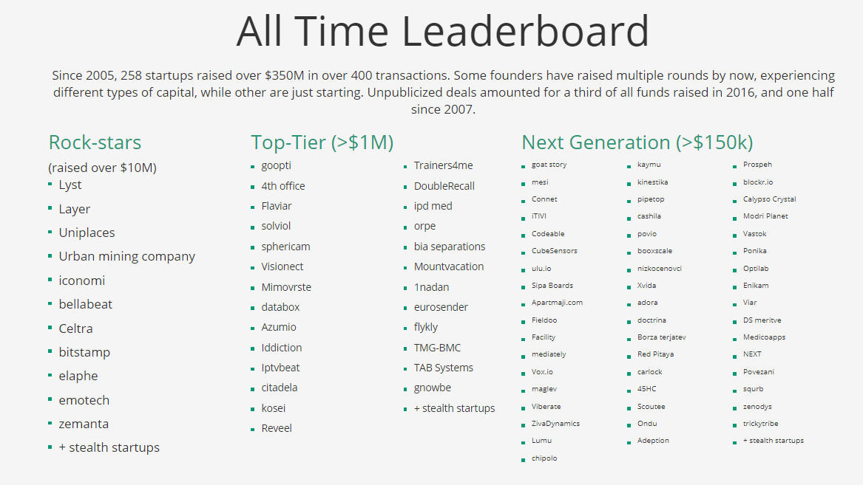

Figure 5: The best startups from Slovenia (Špetič, 2017).
The majority of the startups are located in the capital, Ljubljana. Second biggest concentration of startups is in Maribor, which is the largest town in Podravje. Towns of Ptuj and Ormož, the most important towns in Podravje after Maribor are also interesting for startups.

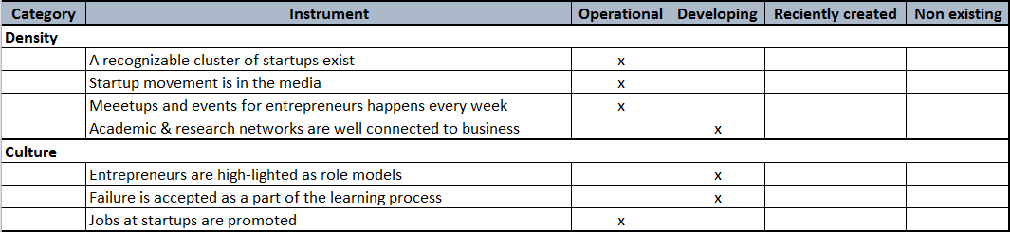

Figure 6: Assesment of density and startup culture in Podravje.

Maribor has University incubator called Tovarna podjemov/Venture factory and cooperative for social entreperneurship called Tkalka/Weaver. There’s also a technological park called Štajerski tehnološki park/Styrian Technology Park In the vicintiy of Maribor.

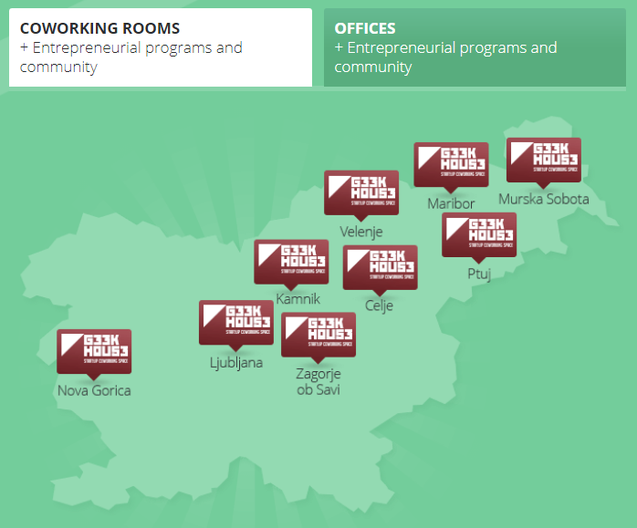

Figure 7: The distribution of Geek Houses offering coworking rooms and individual offices in Slovenia.

Venture Factory is business incubator of the University of Maribor. The services of the university incubator are primarily meant for commercializing business ideas of students, researchers and professors of the university as well as ideas of other innovative individuals.

Venture Factory is the leading partner of the international business conference PODIM and the national platform Start:up Slovenia with the competition Start:up of the year, organised in collaboration with partners. In 2011, it entered into a strategic partnership with Technology Park Ljubljana, which made the latter a co-carrier of the programmes mentioned above. They also developed additional national programmes in collaboration (Start:up Geek House and Go:Global Slovenia).

Tkalka/Weaver as alternative office building in the very heart of Maribor has reopened its gates in 2014 to a picturesque collage of organisations, initiatives and individuals who inhabit its premises in diverse processes of cooperation and in multifarious aspects of co-working. Fundamentally diverse activities of over 100 individuals and of more than 25 organisations inhabiting Tkalka/Weaver thus intertwine, connect and intersect in the organic atmosphere of a working and living habitat. Tkalka/Weaver thus stands for both the edifice it designates and the process it embodies: it is co-working in ceaseless formation; it is a delicate fabric of professional, conceptual and existential variety; it is supportive environment for socially engaged work and life.
As incubator of change on the total surface of 2500 m², Tkalka/Weaver resonates in the polyphony of entrepreneurship and social economy, tourism, sustainable development, non-governmental sector, consultancy services and advocacy, environmental programmes, intergenerational initiatives, human resources development and employment strategies, local environment and its products. Fluid intertwinement of multi-coloured threads woven by Tkalka/Weaver has given birth to a new platform of social relations where life and work go hand in hand, embedding its offices, halls and stairways with solidarity and human dignity.

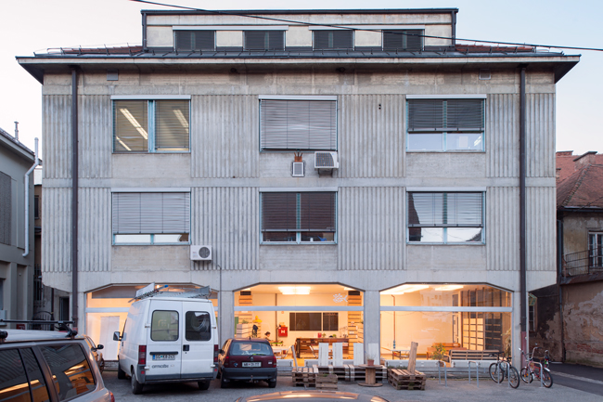

Figure 8: Tkalka/Weawer in Maribor, a social innovation cooperative.

There are events for entrepreneurs every week in Maribor. Maribor is only 30 km from Ptuj and another 20 km from Ormož. Many startups from Ptuj go to Maribor to the events and meetups.

There are no business incubator in Ptuj, but the startups community is addressed by Start:up Ptuj Programmes and events, which are jointly organised by SRC Bistra Ptuj, Venture factory and School Centre Ptuj. There’s also a vibrant ICT startup community around companies Intera, Ptuj and an international startup Databox located in Ptuj.

A business incubator founded by municipality of Ormož gathers startups in Ormož, including social entrepreneurs.

Iniciative Start:up Slovenia with their branches in Maribor and Ptuj launches a lot of news feeds from the startup community and the startup ecosystem resulting in constant presence of startup stories in media.

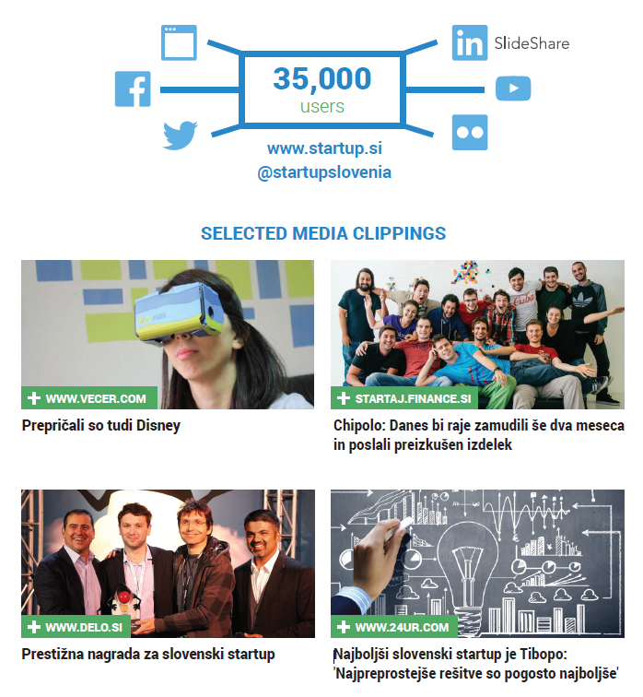
Figure 9: Startup movement is constantly present in Slovenian media.

Funding

Entrepreneurs use different sources of finances and different combinations of these sources to finance the startup of their ventures. The entrepreneur’s personal funds are one of the most frequent primary sources of financing nascent and new ventures. This usually entails using one’s own savings, working at home, seeking free-of-charge advice, and the like. The reason for the use of personal funds may be one’s personal choice, but quite often entrepreneurs are forced to do this because they do not have access to any other external sources of finance.

In Slovenia, the percentage of new entrepreneurs who use their own funds to finance a new venture is 73% (Rebernik, 2016).
When it comes to financing, the Slovene Enterprise Fund joins in with its products during these times. It offers startups products P2, SK75 and SK200, which jointly provide up to €329.000 of seed capital per company, including an intense advisory, educational and mentoring supporting programme. Public programmes are planned and coordinated by the Ministry of Economic Development and Technology.
The implementation and promotion of these public programmes is done by the Start:up Slovenia Initiative, which is an active connector and promotor of all public and private stakeholders in the Slovenian startup ecosystem. With the activities listed above, in addition to its membership in the European Startup Network, Start:up Slovenia and its partners (Venture factory from Maribor, Podravje) are attempting to put Slovenia on the map of established startup hubs.
The Ljubljana-based ABC Accelerator has a branch in San Jose in addition to its office in Munich and domicile in Ljubljana.
Alongside ABC Accelerator, other private programmes, such as CEED Slovenia, Coinvest and the Business Angels of Slovenia club, have also contributed to the quick growth of the ecosystem and the growing number of global successes of Slovenian startups.
Entrepreneurship infrastructure and consulting are excellently managed by Slovenian innovative environment subjects - university incubators, regional entrepreneurship incubators and technology parks that work under the auspices of the public agency SPIRIT. The gap of equity financing is the largest in the early seed stages of startups.
There’s also an annual business conference organised in Maribor. PODIM is the biggest and most influential startup conference in the Alps-Adriatic region offering an intense 2-day experience of connecting, learning, motivation, and positive entrepreneurship energy. It’s the only event that annually gathers the most active stakeholders of the Alps-Adriatic startup ecosystem and enables them to host their global partners in a home environment. PODIM is also an effective platform for investing into the most promising startups from the region, as well as for actively connecting startups and corporations.
A part of PODIM is also the announcement of the Slovenian Startup of the Year, which is the project of active stakeholders of the Slovenian startup ecosystem. Their role is to participate in the nomination of candidates for the award as well as national and international promotion of finalists and the recipient of the title. The main organizer of the project is Initiative Start:up Slovenia, joined by the ABC Accelerator as the co-organizer in 2016. Already traditionally, the award is organized with the support of the Slovene Enterprise Fund and the Ministry of Economic Development and Technology.
The Slovenian Startup of the Year award can be won by a Slovenian innovative startup company with potential for growth on the global markets. With the award, the key stakeholders of the Slovenian startup ecosystem wish to highlight and reward companies and teams whose persistence, globally recognizable achievements and a bold development vision are a role model in the national and international startup environment.
The recipient of the title Slovenian Startup of the year is an ambassador of the Slovenian startup community. Organizers of the award give active PR and other support to the recipient of the title, and the received crystal statue reminds the winner that they aren’t promoting only their successes in the media and at events at home and abroad. They’re also promoting the Slovenian startup community.
There are also other startup competitions with rewards in Podravje, some worth mentioned are:
- The best entrepreneurial idea organised by Manager Club Ptuj
- The best student’s business idea organised by SRC Bistra Ptuj and School Centre Ptuj

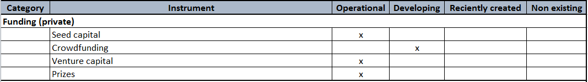
Figure 10: Assesment of the funding instruments in Podravje.

Regulatory environment

Government policies and regulations play a key role in creating a more favourable entrepreneurial environment. The regulatory environment is determined for the whole Slovenia by the state and there’s no effective regional or local measures.

The World Bank’s Doing Business Survey (World Bank, 2017) measuring and comparing regulatory conditions for doing business ranks Slovenia in 30th place among 190 nations. Slovenia is among the top five countries with the least number of procedures required to start a new business. Not only that: it is the cheapest place on the planet to launch a new corporation. Another advantage highlighted by the report is Slovenia’s high level of security for investors.

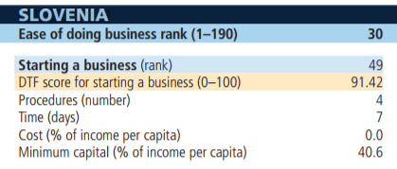
Figure 11: Ease of doing bussines in Slovenia (World Bank, 2017).

National experts involved in GEM 2017 agree that Slovenian policymakers are inclined towards boosting entrepreneurial activity at the national level and even more at the local level; however, they also believe that this interest is not sufficiently implemented in practice and also not in all areas. In 2016, the majority of experts’ recommendations for the improvements of government policies (72.2% of all statements) related to the profound tax reform as well as the removal of administrative obstacles and the simplification of bureaucracy, both of which are a hindrance for SMEs and have a constraining effect on entrepreneurial intentions.

The national government has launched several initiatives to improve the business environment for all entrepreneurs and business owners. These initiatives include:

- E-VEM contact points: The E-VEM portal offers electronic services related to business creation and registration. The portal allows for online registration and acts as an information portal where entrepreneurs can access information on business start-up and development, as well as ceasing operations
- E-davki – electronic tax operations (e-tax portal): The e-tax portal enables convenient, easy and secure completion and submission of tax forms from the user’s computer at home or in the office. It is a safe web service that fully substitutes for the relevant paper work. The portal offers also the information on the services that can be done electronically
- “Stop birokraciji” website (“Stop bureaucracy”): The Stop bureaucracy website is operated by the Ministry of Public Administration and aims to inform the public about initiatives to reduce administrative burdens for companies in Slovenia.

The establishing, managing and organization of companies is regulated by the Commercial Companies Act, which is harmonized with the EU Acquis Communitaire. The court registration of companies is regulated by the Court Register Act and the Decree on the Entry of Companies and Other Legal Entities in the Court Register.

The Companies Act provides for the following organization forms:
- Limited liability company (Družba z omejeno odgovornostjo – d.o.o.) – the most common form,
- General partnership (Družba z neomejeno odgovornostjo – d.n.o.),
- Limited partnership (Komanditna družba – k.d.),
- Joint-stock company (Delniška družba – d.d.),
- Partnership limited by shares (Komanditna delniška družba – k.d.d.).

Since 2006, the establishment of a European company (SE) is possible in Slovenia. All forms of companies may be established by any domestic or foreign, legal or natural person. The law prescribes the minimum or maximum number of founders for an individual type of company.
An individual may also establish and register a sole trader enterprise in Slovenia ("samostojni podjetnik s.p.").

A simple one-personal or multi-personal LLC company, and even more popular a sole trader enterprise in Slovenia can be registered at VEM (Vse na Enem Mestu, i.e. one-stop-shop) offices. It can be done also online by the founders, if they have a digital certificate.

Services of the e-VEM portal and VEM offices are free of charge.

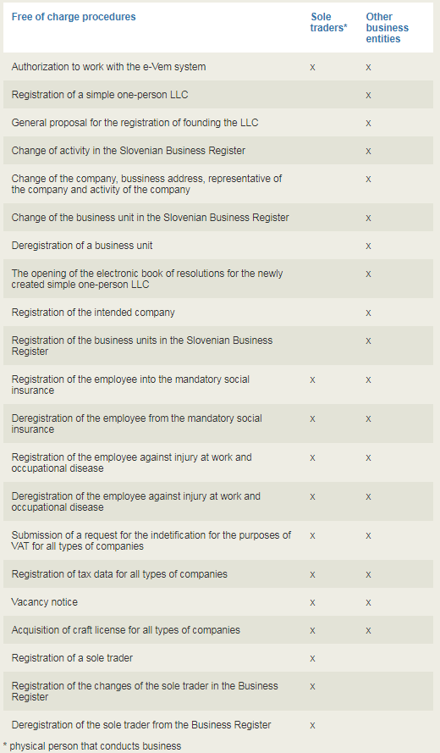

Figure 12: Services for startups at VEM offices free of charge.

Registration of other different types of companies (more complexed types of companies) can be done at Notary offices. Services at the Notary’s Office are paid in accordance with the Notary's Tariff.

Citizens of EU, EEA member states and Switzerland do not require a work permit to work in Slovenia. Workers from those countries have a status equal to that of domestic workers when it comes to employment or searching for employment. The only obligation employers have in connection with workers from those countries is that they have to register them with the Employment Service of Slovenia for record-keeping purposes. The employer must perform the registration within eight days of the commencement of employment using the TUJ/EU-zap form. In the event of the early termination of employment, the employer must perform the de-registration of the foreigner’s employment relationship using the same form. EU citizens also do not require a residence permit; they must simply register their stay with the administrative unit.

According to the Slovenian Industrial Property Act, patents are granted for any inventions, in all fields of technology, which are new, involve an inventive step and are susceptible of industrial application. Apart from excluding discoveries, scientific theories, mathematical methods, and other rules, schemes, methods and processes for performing mental acts as such, protection can be denied only for inventions the exploitation of which would be contrary to public order or morality or for inventions of surgical or diagnostic methods or methods of treatment practised directly on the living human or animal body.

Patent protection for Slovenia can be obtained in three ways: by filing a national application with sipo, by filing a European patent application with the European Patent Office under the European Patent Convention, and by filing an international application with wipo under the Patent Cooperation Treaty. After the abolishment of pct national phase, the patent protection in Slovenia on the basis of such application can only be obtained through Euro-pct route, with designation of Slovenia on entry into the regional phase with the European Patent Office.

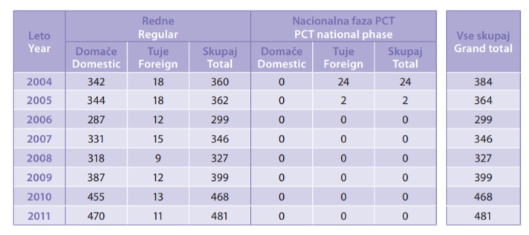
Figure 13: National patent applications.

In Slovenia, the Ministry of Education, Science and Sports is in charge of R&D policy, especially when it comes to research activities in the public sector, while the Ministry of Economic Development and Technology is responsible for the promotion and support of innovation activities. Due to its role in RIS3, the Government Office for Development and European Cohesion Policy is increasing its role in R&D policy through the coordination of the Smart Specialisation Strategy, approved in 2015. These institutions are all involved in R&D&I funding.

The R&D&I performers in Slovenia can be divided into three groups: universities and higher education institutions (HEIs), public research organisations (PROs) and research units within business enterprises. The PRO sector is relatively strong and outweighs the higher education sector (HES). 15 PROs, founded by the government, get block funding for basic R&D expenditures (no more than 10-30% of total income). This stems from a past structure in which PROs were the main actors and HEI were primarily focused on teaching. The Slovenian research and innovation strategy (RISS) has suggested that research should mostly be located at HEI (there are 3 public universities in Slovenia, plus 1 private and 1 international (Euro-Mediterranean University of Slovenia - EMUNI) university as well as more than 60 different faculties and/or academies.

In the period 2016 – 2018, Slovenia plans to invest €1.9b through the Operational Programme in accordance with the thematic priorities of the Smart specialisation strategy (RIS3) (€1b on R&D&I, €0.8b on entrepreneurship and €0.05b on human resources) (Bučar and González Verdesoto, 2017).

The Ministry for Economic Development and Technology's financial support has been detailed in an implementation programme. One of the important tasks is “the establishment of complex and integrated entrepreneurial and innovation support environment for potential entrepreneurs and firms at all stages of growth and development” (MEDT, June 2016). These services to entrepreneurs are to be provided through a restructured and modernised VEM offices. Together with other institutions of support environment they will provide consultancy and training to innovative start-ups, process improvements, internationalisation, etc. The Ministry estimates that this type of support will require €62.4m until 2020 (ibid).

By 2015, the business sector funded 69.2% of the total R&D expenditure, with most of these resources going back to the business sector. As R&D performer, the business sector was able to draw also on government funds and funds from abroad. In terms of human and financial resources, R&D in the business sector has increased significantly over last ten years and it outweighed the HES & PRO, with a 53.0% share of researchers (FTE) and 77% share of total R&D performed in 2015 (ibid).

66% of total R&D in the business sector was performed in 2014 in the manufacturing sector and 32.4% in services, which is a considerable structural change since 2008, when the share was 82.7% and 16.3% respectively. Within the services sector, 72.7% of R&D is done by scientific, technical and other business activities and another significant R&D performer is information & communications, especially software activity in services (21%). Within manufacturing, traditionally the most important industry is the pharmaceutical one, with nearly €163m (35.7% of the R&D in the manufacturing sector), followed by the electrical appliances (16.8%), motor vehicles (10.6%) and computer, optical and electronic industry (8.9%). The increase in business R&D was at least partly due to higher R&D tax subsidies (20% in 2006, 40% in 2010 and 100% in 2012).

While only 10% of those eligible for tax subsidies were large companies, they received two thirds. On the other end, micro enterprises represented more than half of those that claimed subsidies but they only accounted for less than one tenth of the amount, showing however their use of this tax scheme.

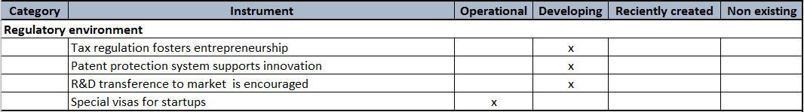

Figure 14: Assesment of the regulatory environment in Slovenia, also valid for Podravje.

Support services and business training

The Initiative Start:up Slovenia is an active facilitator and promoter of public and private stakeholders of the Slovenian startup ecosystem. In their manifesto they strive to set a social goal for Slovenia that until 2020 they will annually:
- Create 1,000 new jobs in start-up companies in Slovenia;
- Connect at least 50 start-up companies with the most important start-up ecosystems in the world;
- Create or attract at least 150 start-up companies with global potential

The iniciative Start:up Slovenia has branches in Podravje, i.e. Start:up Maribor and Start:up Ptuj.

As already described in chapter: 1 Startup ecosystem Podravje region has operational support services and bussines training programs for startups in the biggest region settlements such as: Maribor, Ptuj and Ormož.

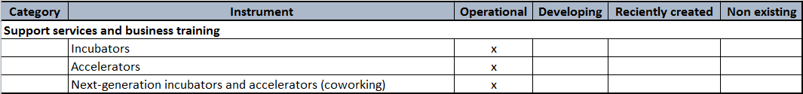

Figure 15: Assesment of the support services and training for startups in Podravje, Slovenia.

Institutional support

Talent

Skilled people are the driving force of Slovenian innovation. Talents are needed as driving forces in startups. Skilled workers, entrepreneurs, universities and research institutes are central to a country’s innovation system. Highly skilled workers are needed to conduct research that can lead to innovations for commercialisation as new products and services. They also embody the know-how needed to adopt, adapt and implement innovations and new technologies in the workplace, thereby boosting profits, productivity and growth. Strong basic cognitive and social and emotional skills are needed in the general workforce to facilitate the adoption of new technologies and work processes. Partnerships between universities/research centres and firms are essential to transfer new knowledge and train the highly skilled workers and entrepreneurs that firms need to innovate and grow.

Entrepreneurship behaviours and skills are needed to encourage individuals to take the risks that are needed to bring new ideas to market. The education system drives entrepreneurship by helping to develop an entrepreneurial mind-set and providing practical competences and skills needed to start and grow new ventures.

Labour market conditions in Slovenia continue to improve and the employment rate finally returned to its pre-crisis rate in the first quarter of 2017, nearly ten years after the global financial crisis erupted. The recovery remains very uneven across countries and different groups within the workforce.

According to There are some risks related to the labour market in Slovenia, such as:
- Labour Costs: High employment costs and a rigid labour market erode Slovenia's competitiveness as an investment destination in relation to other Central and South East Europe manufacturing-orientated countries. The country has the wider emerging Europe region's second highest minimum wage and some of the lowest levels of worker productivity, weighing on profit margins. The strong protection of workers' rights in local labour legislation and high unionisation rates make it more difficult for employers to fire workers.

- Availability Of Labour: Currently businesses face few difficulties sourcing labour in Slovenia; the country does have a small population but workers can be sourced from other EU countries. Over the long term businesses will face increasing recruitment difficulties. These will be driven by the countries declining population demographic, low urbanisation rates, and high emigration levels.

- Education: A significant portion of the Slovenian population has a tertiary education and education at secondary school level is almost universal. While a shortage of tertiary educated graduates within technical fields exists, overall employers will enjoy access to a labour pool with a solid skill set.

Slovenia’s wage-determination system is characterised by sectoral bargaining within a highly co-ordinated setting with the (tripartite) Economic and Social Council issuing wage guidelines. In addition, the government has the possibility of administratively extending wage agreements.

Upon completing compulsory education (typically at age 15) students in upper secondary education can pursue academically orientated general education (with the aim of progressing to university) or vocational education. Slovenia’s vocational training system is broader in scope than in most other countries, with students having the flexibility to continue to tertiary education. Programmes involve either three years of traditional vocational training (for instance in plumbing), or four years of “technical” training (such as for technicians). In 2016 an apprenticeship pilot scheme was introduced. The three-year programmes have wellestablished links with local employers, as students spend 25% of course time in work-based practical training in addition to 15% of programmes’ content being determined by schools in co-operation with local companies (Ministry of Education, 2015). In contrast, workplace experience is a minor part of the four-year ‘technical’ programmes. Moreover, 90% of those in four-year programmes advance straight to tertiary education, despite the vocational aspect of the programmes. However, their access is typically restricted to courses in the same field as their secondary studies.

The three-year programmes prepare students for the current needs of the labour market, as is shown by their good employment rates. However, vocational graduates lack advanced literacy and problem-solving skills, and are average in terms of numeracy, making it difficult for them to succeed in a changing and increasingly high-tech environment. Acquiring such skills is important for life-long learning, which in turn increases occupational mobility (OECD, 2017a).

Slovenia has experienced a large expansion in the proportion of tertiary graduates. Paying universities a lump sum per full-time undergraduate student enrolled creates incentives for them to enrol as many students as possible and to ensure they continue studying. At end-2016 the funding formula was changed so 75% of funding comes in the form of a fixed amount per institution and the rest is related to student enrolment and output indicators, such as scientific output, employment prospects of graduates and industry collaboration. Increasing the share of funding dependent on graduates’ labourmarket performance would help to better align the supply and quality of education with the needs of society. Publishing such labour-market scores would help students identify the best institutions in this respect.

The higher education system is an important component of a country’s innovation system. Universities contribute to research and innovation in a number of ways. First, they provide individuals with high levels of basic cognitive and social and emotional skills, which allow them to adopt and adapt to new technologies and work processes. Second, they train the highly skilled researchers that firms need to conduct their own research and adopt new innovations. Third, universities conduct basic and applied research that can eventually be commercialised in a variety of ways.

Slovenian tertiary institutions could be doing more to ensure that firms have access to the skilled workforce they need to innovate and grow. A workforce with a good mix of cognitive, social and emotional, and discipline-specific skills is needed to drive innovation. The percentage of young adults in Slovenia with tertiary education is growing steadily, and the share of Slovenian tertiary graduates who have completed their studies in a science, technology, engineering and mathematics (STEM) fields exceeds the OECD average (OECD, 2015a). However, the mean cognitive skill level of young tertiary graduates (aged 25-34) in Slovenia is lower than the OECD average. Additionally, there are concerns that many young adults in Slovenia are not developing the strong social-emotional skills that employers need.

Slovenia trains a large number of highly skilled researchers. Approximately 2% of all 25-44 year-olds in Slovenia hold a doctorate degree, above the OECD average of 1% (OECD, 2015b). An above-average share of these doctorate holders has completed studies in a STEM field (OECD, 2015a).

Adult education and life-long learning promote inclusiveness by allowing older workers to remain employable and are needed as older Slovenians (aged 55-64) perform poorly in literacy, numeracy and problem solving (ibid).

Slovenia is devoting a high and growing share of its national wealth and highly skilled people to innovation. Its expenditure on R&D is close to the OECD average and has grown substantially (ibid). Slovenia has a high share of R&D personnel (researchers, technicians and support staff) in the total workforce, and this share has grown faster since 2003 than in any other OECD country (ibid).

Slovenia has introduced ambitious strategies to improve its innovation performance, and to better capitalise on its highly skilled R&D workforce. However, implementation of these strategies is still incomplete, due to financing and legislative challenges.

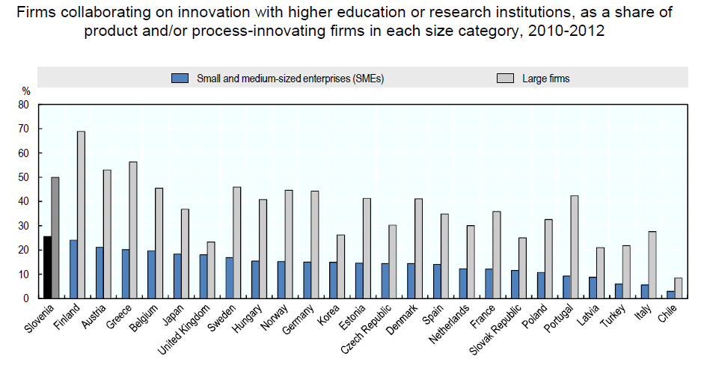

Figure 16: Public and private innovators collaborate quite frequently in Slovenia (OECD, 2017a).

Overall, collaboration and partnerships on innovation between higher education and the private sector is strong in Slovenia. Active participation in joint innovation projects is a key conduit for innovation-related knowledge flows between the public research sector and businesses. Slovenia has the highest rate of SME collaboration in innovation with higher education or research in the OECD, and the fourth-highest rate for large firms (Figure 16). Direct funding of public research by industry – in the form of grants, donations and contracts – aims to influence the scope and orientation of public research, generally steering it towards more applied and commercial activities. Business-funded R&D in the higher education and government sectors is among the highest in the OECD (OECD, 2015a).

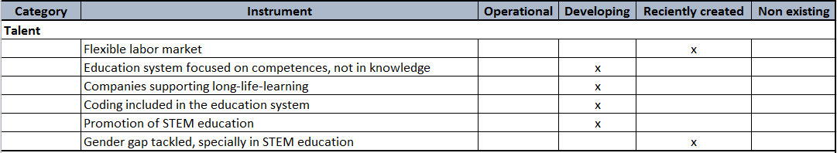

Figure 17: Assesment of the talent in Slovenia, also valid for Podravje.

Financing

Start-up companies have different sources of financing available, depending on the stage of development (idea, prototype, growth…), business reach (regional or global) and the type of industry they are working in. All these instruments are available across all Slovenia, including startups from Podravje.

The Initiative Start:up Slovenia is an active facilitator and promoter of public and private stakeholders of the Slovenian startup ecosystem. In collaboration of private and public, it carries out and promotes national programmes for supporting innovative entrepreneurship. With all listed activities and partners, they have an ambition to place Slovenia on the map of established European startup hubs.

The leading partners of the Initiative are the strategically connected Venture Factory and Technology Park Ljubljana. Members of the Initiative are Primorska Technology Park, Pomurje Technology Park, Savinja Region Incubator, SAŠA Incubator and RC IKT. The structure and members of the Initiative are presented online at http://www.startup.si/en-us/stakeholders.

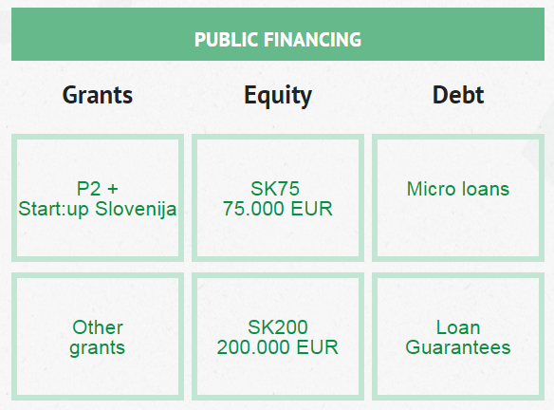
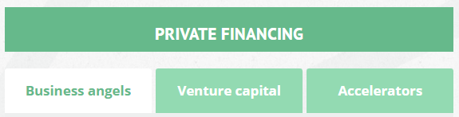

Figure 18: Public and private financing of startups in Slovenia.
The Slovene Enterprise Fund’s tender P2 provides a €54,000 subsidy to start-up companies with an innovative idea, with the purpose of developing a product in the span of two years. P2 are grant funds, transferred to the entrepreneur’s transaction account once a year, after a confirmed report on use of legitimate expenses. The P2 grant is connected to the competition Start:up of the year, where entrepreneurs can collect up to 25 points out of 100 possible in order to apply to the tender.

Entrepreneurs also have other grants available for financing development and other business expenses, tendered by government agencies, funds, municipalities and other institutions. The amount of the awarded non-refundable funds and the percentage of co-financing depend on the tender.

Equity financing is supported by accelerators, business angels and venture capital funds. The SGH accelerator is intended for innovative business teams with global ambitions and, in collaboration with the Slovene Enterprise Fund, provides a convertible loan in the amount of €50,000, experienced start-up mentors, a co-working work place, an excellent boot-camp programme and administrative help.

The GG accelerator offers everything necessary for successfully starting fast global growth to companies that have already found their product-market fit: €200,000 of capital, an excellent workshop for preparing for an investment and fast growth, a personal start-up mentor, comprehensive administrative help, use of infrastructure and active promotion at home and abroad.

The international accelerators are also very important for Slovenian IDE startups. They are mostly European and American accelerators offering diverse programmes, investment amounts, and a mentorship and partnership network. The initiative frequently organises preliminary workshops for applying to individual accelerators.

Business angels are experienced individuals who use their knowledge, experiences, network of connections and capital to enter start-up companies and give them the so called “smart” capital to help them with development and fast growth. A business angel gets an ownership share in the company in exchange for the invested capital. They enter companies with an innovative product, experienced team, focus on the global market and the potential for fast growth.

The Silicon Gardens Fund, open in 2014, is planning five to ten investments into start-up companies in the near future. It was founded by successful Slovene and USA entrepreneurs. On their webpage http://silicongardens.si/ecosystem2016/ they published the results of investments in Slovenian startups in 2016.

Venture capital funds differ from business angels in the fact that they usually enter the company in the phase of fast growth and globalization. Capital investments are thus significantly larger from angel investments. The amount of the capital investment is suitable to the acquired equity share. They enter companies with an innovative product, experienced team, focus on the global market and the potential of fast growth. The list of venture capital funds and their investments are listed online at: http://www.startup.si/en-us/venture-capital.

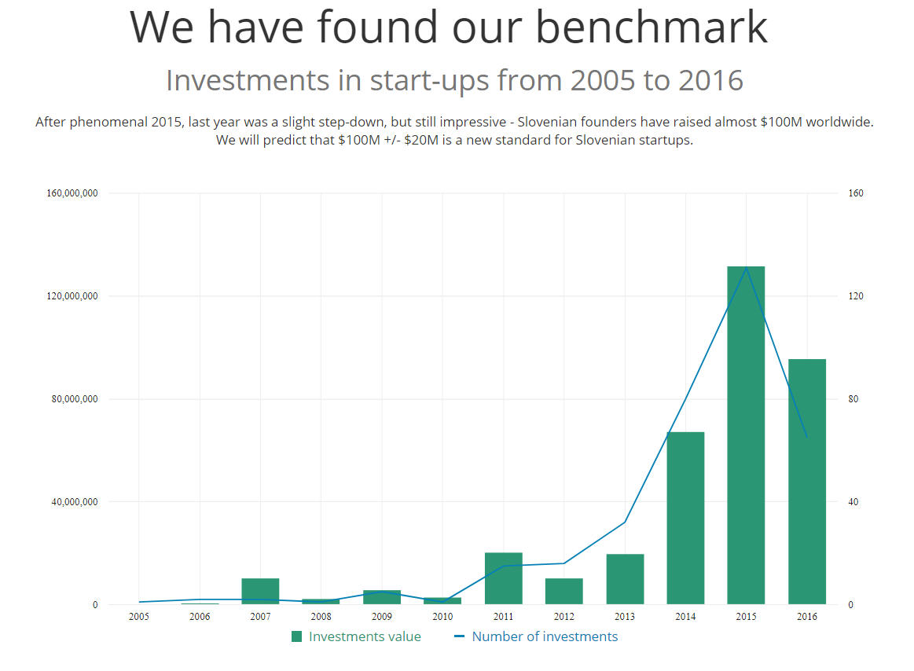
Figure 19: Investments in Slovenian startups – data gathered by Silicon Gardens Fund.
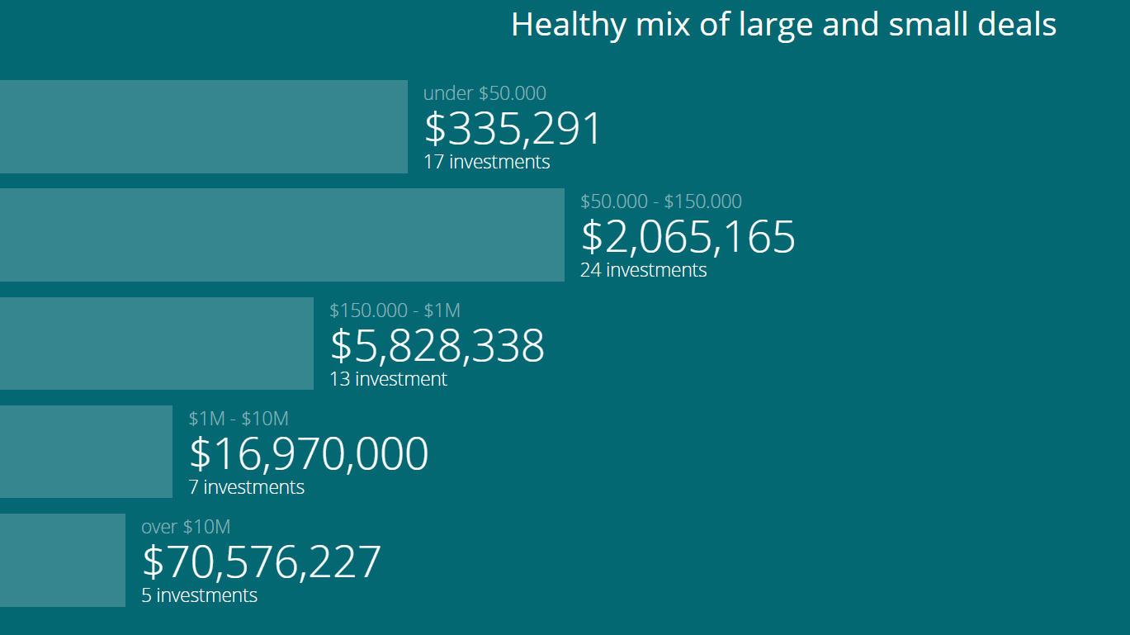

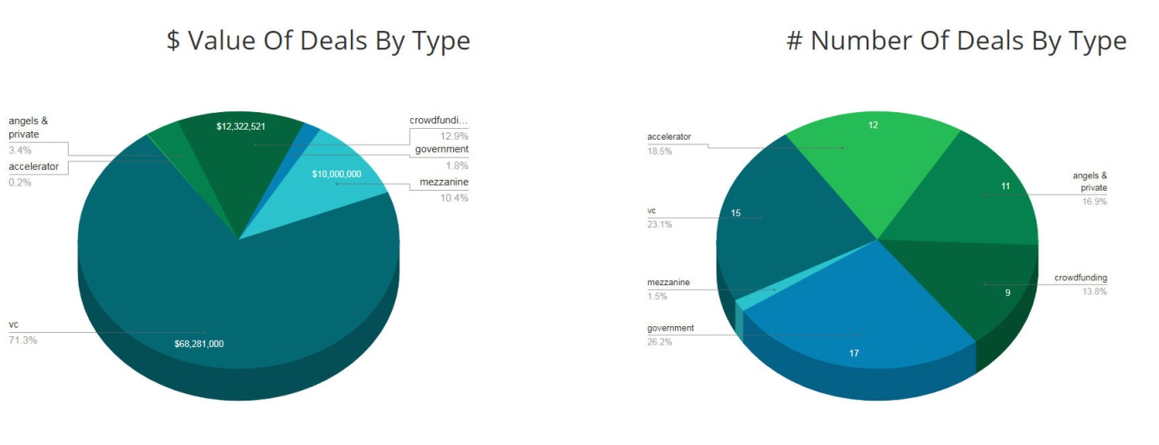
Figure 20: Characteristics of the investments in Slovenian startups in 2016 – data gathered by Silicon Gardens Fund.

A debt financing is also available by startups in Slovenia. The products interesting for startups are usually the combination of public and private financing.

Besides leasing, loans are the most frequent debt financing source, but due to their nature, they are less suitable for startup companies. The Slovene Enterprise Fund uses tenders to offer micro loans in the amount of up to €25,000, meant to provide SMEs with easier access to financial resources for financing growth and development of the company, investments and current business. The advantage of micro loans lies especially in simplified terms of approving state aid, lower interest rate, lower insurance requirements, longer loan maturity and the possibility of benefiting from payment deferment.

Insuring bank loans with the warranties of the Slovene Enterprise Fund allows technologically innovative companies an easier access to a bank loan. The loan, insured with the fund’s warranty, is more favourable to companies because of lower insurance requirements, lower interest rates, longer loan maturity and the possibility of deferring payment upon returning the loan.

Crowdfunding using Kickstarter is a known concept to Slovenian startups. There are none Slovenian crowdfunding platform and the formation of one is questionable because of the size of Slovenia.

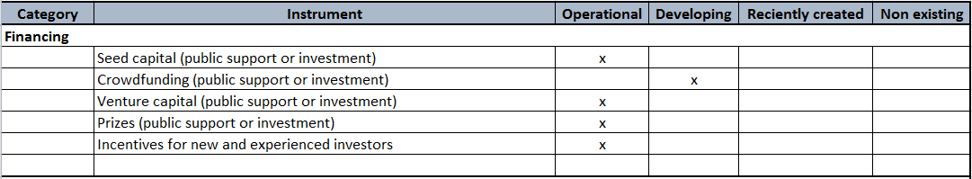

Figure 21: Assesment of the institutional financing in Slovenia, also valid for Podravje.

Integrated public/private programmes, support services and business training

SPIRIT Slovenia, set up in 2013, aims to create an environment in which enterprising and innovative individuals bring their ideas to fruition. SPIRIT co-ordinates and monitors support for companies in Slovenia, including the e-VEM “one-stop-shop” for entrepreneurship promotion, university incubator services, and supporting activities in the area of technology development and innovation. SPIRIT provides:
- The Slovenian Innovation Forum: a two-day business event to identify and realise entrepreneurial and innovation synergies at the national level, including key players in the innovation environment, such as excellence centres, competence centres and development centres of the Slovenian economy.
- The European SME Week: an EC campaign held simultaneously in 37 European countries. SPIRIT Slovenia is the national co-ordinator of European SME Week in Slovenia. Its goals are to promote the notion that entrepreneurship is a way of boosting employment, identify possible entrepreneurs, promote entrepreneurial activity and business networking, and strengthen the positive image of entrepreneurs in the media.
- Information portals and handbooks: The Entrepreneurship Portal (Podjetniški portal –www.podjetniski-portal.si) is a tool for communicating information about entrepreneurship.

Slovenia has undertaken a range of short-term entrepreneurship education initiatives to develop skills and positive attitudes for entrepreneurship. Continuity in effective entrepreneurial programmes will be important in achieving these objectives.

The extracurricular Ustvarjalnost, Podjetnost, Inovativnost (UPI) course supported the development of entrepreneurship and innovation, in courses delivered by mentors specifically trained in entrepreneurship education. It ran from 2010‐2012 in Slovenian primary and secondary schools, and was Slovenian policy makers’ first co-ordinated step towards a systematic approach towards innovation and entrepreneurship education. The activities engaged 1,135 primary school pupils, showed a positive impact on the creativity, flexibility and entrepreneurial skills of students, and affected students’ choice of secondary education.

EnterYOUTH was a bilateral entrepreneurship training project developed between partner organisations from Slovenia and Croatia. The project ran between 2014 and 2015, with a budget of over €200,000. The main aim of the initiative was to promote and support the acquisition of entrepreneurial skills by secondary and higher education students, and also young unemployed people who intended to start a business at some point in their career. The project engaged local firms and helped create new partnerships, and reached 200 young people.

Other programmes with similar goals have included the Company Programme, Our Community, and Training for the Entrepreneurial‐Hearted and the Brave. The Institute of the Republic of Slovenia for Vocational Education and Training has set up the Opening Doors project (Vrata odpiram sam), co-funded via the European Structural Funds and the state budget. The project encourages young people to become self-employed and promotes an entrepreneurial mind-set and innovation among young people and their teachers.

Table 1: Short-term entrepreneurship education initiatives in Slovenia
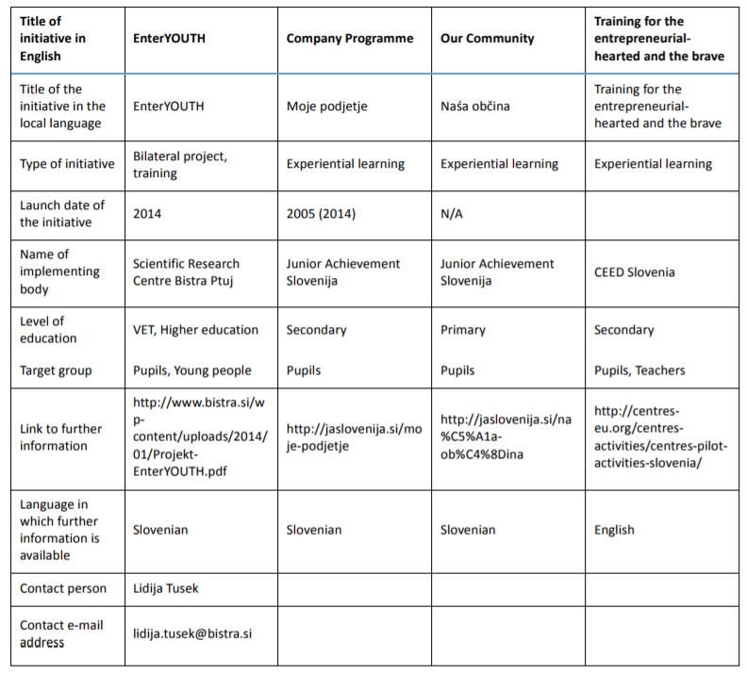

The Iniciative Start:up Slovenia, the most active facilitator of collaboration between public and private stakeholders of startup ecosystem in Slovenia made a roadmap of startup support services and business training programmes offered by stages of development (Figure 23). One of the most active members of the Iniciative is Venture factory from Maribor, Podravje.

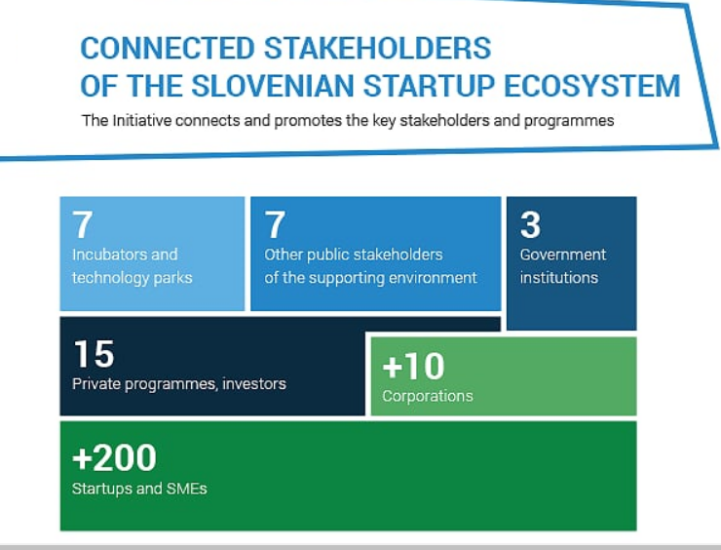

Figure 22: Initiative Start:up Slovenia facilitates the Slovenian startup ecosystem.

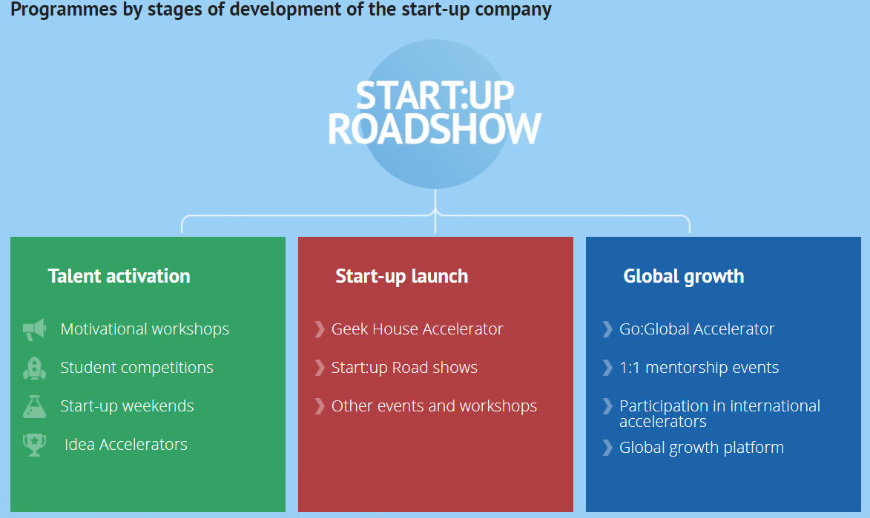

Figure 23: Support services and business training for Slovenian startups.

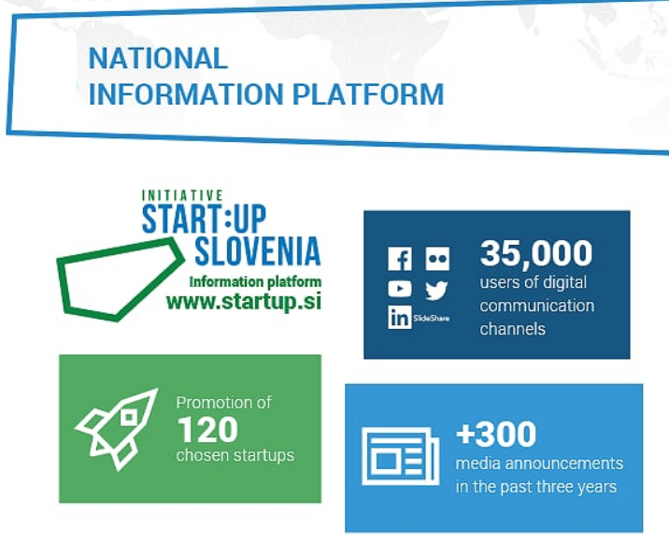
Figure 24: The results of Initiative Start:up Slovenia.

Social entrepreneurship has become one of more important elements for society in the last few years. It is becoming more and more popular also in Slovenia.

The most common and the best developed support mechanism for the Slovenian social enterprises are consultancy services – there are many consulting firms which are counselling on the field:
- Potential social entrepreneurs – consultancy services consist of proper development of the business idea, functional business education for potential entrepreneurs, help with preparation of the business plan.
- New entrepreneurs – consultancy services consist of business counselling, business education (functional knowledge for running the business) and help with preparation of business plans for new investments or the expansion of the business.

Table 2: Support environment for social entrepreneurship in Podravje.
Institution | Supporting services
Center for alternative and authonomous production – CAAP | Incubator for social enterprises and social – innovative organizations. They have supported the establishment of many cooperatives.
Development community Tkalka | Education, co-working, incubator services, social practice and inter-generational cooperation
The Slovenian forum of social entrepreneurship | The “umbrella” organization at the national level; merges about 60 members (social enterprises); plan of development of social entrepreneurship; education and promotional activities

Table 3: Distribution of social enterprises and social entrepreneurship support organizations in Slovenia - by regions.
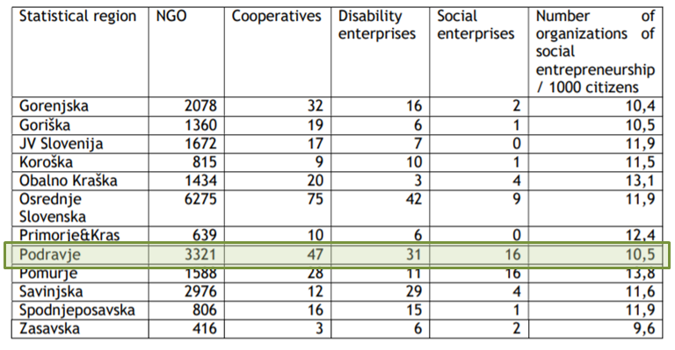

The Entrepreneurship fund of the Republic of Slovenia and the Slovenian government announced the first public tender for financial microcredits to social entrepreneurs’ companies in March 2016.

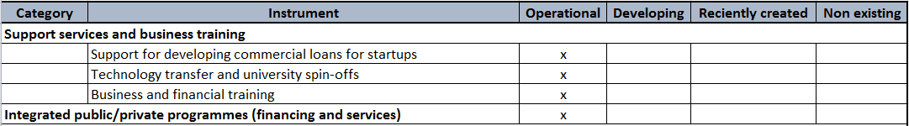

Figure 25: Assesment of the institutional support services, business training and integrated public/private programmes for startups in Slovenia, also valid for Podravje.

Demand-oriented support& market creation: Public procurement and other

Slovenia has a relatively centralized public procurement system of comparatively moderate economic significance. The public procurement tenders in Slovenia are rarely interesting for IDE startups, probably because a large share of public procurement is not subject to competitive tendering.

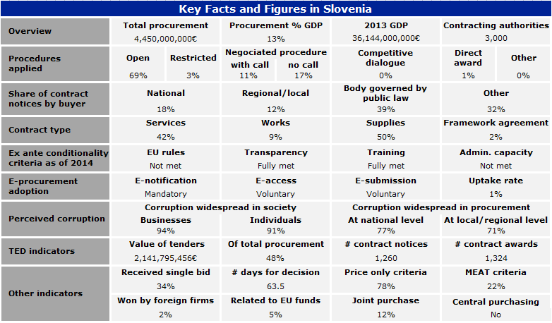

Figure 26: Public procurement in Slovenia (.

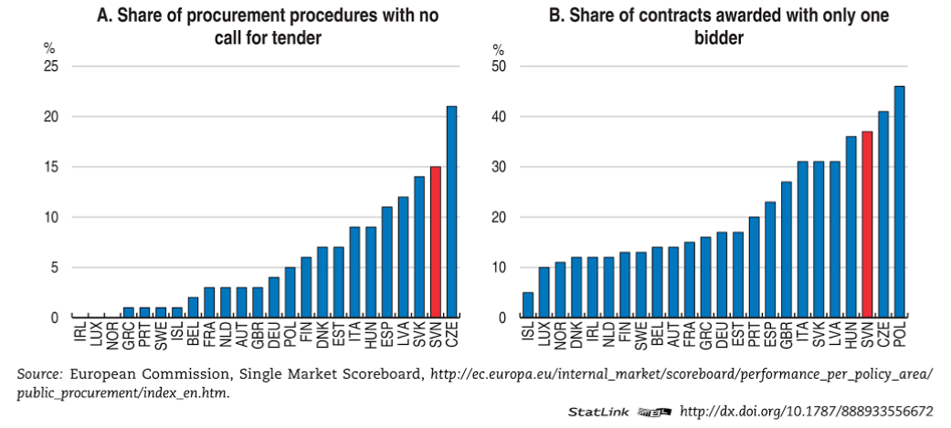
Figure 27: A large share of public procurement in 2016 in Slovenia was not subject to competitive tendering (OECD, 2017b).

Most of the companies do not consider public procurement as a measure to support innovation and public procurement procedures do not have much influence on innovation.

Figure 28: Assessment of public procurement and other demand-oriented support for startups in Slovenia, also valid for Podravje.

Enhancing corporate innovation

The corporate venture capital does not exist in Slovenia. There are some startup communities evolving around some larger companies, one of such is an ICT startup community in Intera, Ptuj. Intera is former start-up company facing problems with acquisition of talents; therefore they started offering a coworking space to startups in 2016.

The new models of enchancing corporate innovation does not exist in Slovenia at the moment.

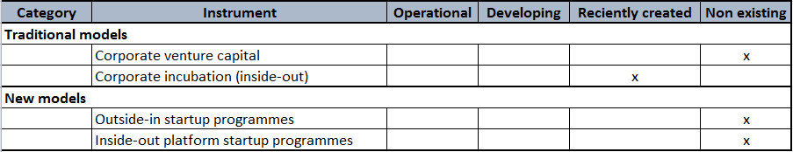

Figure 29: Assessment of enchancing corporate innovation in Slovenia, also valid for Podravje.

SWOT

Strengths | Weaknesses
- Appealing lifestyle  - Low cost of living  - ICT infrastructure  - Good knowledge of foreign languages (English, German)  - Developed national startup ecosystem  - Strong ecosystem in Maribor  - Collaboration and openness  - Famous startups (Outfit 7, Chippolo, Databox…)  - Easy and cheap registration of company  - VEM (one-stop-shop) offices – services for startups free of charge  - Public institutions with wide networks and experiences in collaboration programmes  - International connectivity | - Risk-aversive culture  - Giving-up culture  - Most people in Slovenia would prefer that everyone had a similar standard of living  - No business incubator in Ptuj  - High cost of labour  - Weak local market  - Pushing the necessity entrepreneurship to unemployed  - Lack of sales experience  - Bad understanding of business with decision makers
Opportunities | Threats
- Education of new entrepreneurs  - Corporate startup hubs  - Social entrepreneurship  - Better use of R&D  - Emerging markets  - 4th industrial revolution – innovations | - Brain drain  - Demographics – the ageing society  - Education with lower standards  - High youth unemployment  - Technology over business

CONCLUSIONS

The region of interest in this diagnosis is Podravska statistical region in Slovenia, where 16% of Slovenia’s population lived in the in 2015. The region generated 13% of the national GDP, but GDP per capita was the fifth lowest in the country. The region had slightly less than 26,000 enterprises with on average 4.6 persons employed.

One of the quite deeply rooted Slovenian social norms is the belief that most people in Slovenia would prefer that everyone had a similar standard of living. According to the GEM 2016 successful entrepreneurs are highly respected in Slovenia. Although Slovenians hold successful entrepreneurs in high regard, their belief that entrepreneurship is a good career choice is much lower.

In Slovenia, over half of the adult population trusts in their entrepreneurial capabilities and competences, this ranks Slovenia high in 5th place among the European countries. Unfortunately, this (self-perceived) entrepreneurial potential is not realized, especially in those areas and with such companies that would result in economic growth and new job creation. There are twice as much men as women entrepreneurs in Slovenia. The majority of them are 25-44 years old. There are two most important groups regarding their education; i.e. secondary education and the highest education.

The potential for the creation of a large number of new jobs and a high added value, which both point to the quality of entrepreneurial activity, greatly depends on the entrepreneur’s aspirations and how innovative the firm is when faced with entrepreneurial challenges. In Slovenia, almost half of entrepreneurs believe that they have a product or service which is new for some or even for all of their potential customers. 45% believe that they use relatively new technologies (i.e., technologies available for fewer than five years).

The majority of the startups are located in the capital, Ljubljana. Second biggest concentration of startups is in Maribor, which is the largest town in Podravje. Towns of Ptuj and Ormož, the most important towns in Podravje after Maribor are also interesting for startups.

Maribor has University incubator called Tovarna podjemov/Venture factory and cooperative for social entreperneurship called Tkalka/Weaver. There’s also a technological park called Štajerski tehnološki park/Styrian Technology Park In the vicintiy of Maribor.

There are no business incubator in Ptuj, but the startups community is addressed by Start:up Ptuj Programmes and events, which are jointly organised by SRC Bistra Ptuj, Venture factory and School Centre Ptuj. There’s also a vibrant ICT startup community around companies Intera, Ptuj and an international startup Databox located in Ptuj.

A business incubator founded by municipality of Ormož gathers startups in Ormož, including social entrepreneurs.

Iniciative Start:up Slovenia with their branches in Maribor and Ptuj launches a lot of news feeds from the startup community and the startup ecosystem resulting in constant presence of startup stories in media.

Entrepreneurs use different sources of finances and different combinations of these sources to finance the startup of their ventures. The entrepreneur’s personal funds are one of the most frequent primary sources of financing nascent and new ventures. This usually entails using one’s own savings, working at home, seeking free-of-charge advice, and the like. In Slovenia, the percentage of new entrepreneurs who use their own funds to finance a new venture is 73% (Rebernik, 2016).
When it comes to financing, the Slovene Enterprise Fund joins in with its products during these times. It offers startups products P2, SK75 and SK200, which jointly provide up to €329.000 of seed capital per company, including an intense advisory, educational and mentoring supporting programme. Public programmes are planned and coordinated by the Ministry of Economic Development and Technology.
The implementation and promotion of these public programmes is done by the Start:up Slovenia Initiative, which is an active connector and promotor of all public and private stakeholders in the Slovenian startup ecosystem. The international accelerators and venture capital funds are active in Slovenia and the Business Angels of Slovenia club, have also contributed to the quick growth of the ecosystem and the growing number of global successes of Slovenian startups.
There’s also an annual business conference organised in Maribor. PODIM is the biggest and most influential startup conference in the Alps-Adriatic region. A part of PODIM is also the announcement of the Slovenian Startup of the Year, which is the project of active stakeholders of the Slovenian startup ecosystem.
According to World Bank’s Doing Business Survey (World Bank, 2017) Slovenia is among the top five countries with the least number of procedures required to start a new business. Not only that: it is the cheapest place on the planet to launch a new corporation. Another advantage highlighted by the report is Slovenia’s high level of security for investors.

Annex: List of involved stakeholders

In this analysis the following institutions were involved as stakeholders:
- Tovarna podjemov; Inštitut za raziskavo podjetništva
- Univerza v Mariboru
- Prizma; Tkalka
- Štajerska gospodarska zbornica
- Obrtna zbornica Slovenije; Območna obrtna zbornica Ptuj, Območna obrtna zbornica Ormož, Območna obrtna zbornica Maribor
- Zavod RS za zaposlovanje
- Mariborska razvojna agencija
- Štajerski tehnološki park
- Intera d.o.o.; Kreativnica
- Fürstova hiša
- Šolski center Ptuj, Ekonomska šola
- Manager klub Ptuj
- Javna razvojna agencija Občine Ormož
- Mestna občina Ptuj
- Mestna občina Maribor
- Občina Ormož
- Mestni svet občine Ptuj
- Regionalni razvojni svet za Podravje

Furthermore, the analysis is referring to GEM 2016 for Slovenia, where the experts from the following institutions were involved (Rebernik, 2016):
- Obrtna zbornica Slovenije
- Nova KBM
- Univerza v Mariboru, Ekonomsko poslovna fakulteta
- ZRS Bistra Ptuj
- Mariborska razvojna agencija
- Srednja ekonomska šola Ljubljana
- Ministrstvo za gospodarski razvoj in tehnologijo
- KonektOn d.o.o.
- Plastika Skaza d.o.o.
- Vlada RS
- GoOpti d.o.o.
- 5KA Petra Škarja s.p.
- Združenje Manager
- CubeSensors, CBSR d.o.o.
- Savinjsko-šaleška gospodarska zbornica
- Instrumentation Technologies d.o.o.
- Hranilnica Lon
- Slovenski regionalno razvojni sklad
- Služba vlade RS za razvoj in evropsko kohezijsko politiko
- Enki d.o.o.
- Časnik Finance d.o.o.
- Gospodarska zbornica Slovenije
- Atech elektronika d.o.o.
- Evident d.o.o.
- Fakulteta za management, Univerza na Primorskem
- Ustvarjalnik
- Demt d.o.o.
- TVBeat
- SPIRIT Slovenija
- Revidicom revizijska družba d.o.o.
- Beletrina, zavod za založniško dejavnost
- Mariborski vodovod d.d.
- Fakulteta za družbene vede, Univerza v Ljubljani
- CEED Slovenija, Zavod mreža podjetništva

References

- Kollmann, T./Stöckmann, C./ Hensellek, S./ Kensbock, J. (2016): European Startup Monitor 2016.
- Kollmann, T./Stöckmann, C./Linstaedt, J./ Kensbock, J. (2015): European Startup Monitor 2015.
- Kelley, D./Singer, S./Herrington, M. (2016): Global Entrepreneurship Monitor 2015/16 Global Report.
- Rebernik, M./Crnogaj, K./Širec, K./Bradač Hojnik, B./Rus, M./Tominc, P. (2016): Dynamics of Entrepreneurial Potential, GEM Slovenia 2016, Executive summary.
- Rus, M. (2015): Slovenian Startup Monitor 2015.
- Špetič, A. (2017): Dawn of new Era, http://silicongardens.si/ecosystem2016/ accessed 2.10.2017.
- World Bank (2017), Doing Business 2017: Equal Opportunity for All, http://www.doingbusiness.org/~/media/WBG/DoingBusiness/Documents/Annual-Reports/English/DB17-Report.pdf, accessed 5.10.2017.
- Bučar, M/González Verdesoto, E (2017): RIO Country Report 2016: Slovenia.
- OECD (2015a), OECD Science, Technology and Industry Scoreboard 2015: Innovation for Growth and Society, http://www.oecd-ilibrary.org/science-and-technology/oecd-science-technology-and-industry-scoreboard-2015_sti_scoreboard-2015-en, accessed 5.10.2017.
- OECD (2015b), Entrepreneurship at a Glance 2015, http://www.oecd-ilibrary.org/industry-and-services/entrepreneurship-at-a-glance-2015_entrepreneur_aag-2015-en, , accessed 5.10.2017.
- OECD (2017a), OECD Skills Strategy Diagnosis Report: Slovenia.
- OECD (2017b), OECD Economic Surveys: Slovenia 2017
- Initiative Start:up Slovenia (2017): http://www.startup.si/en-us, accessed 5.10.2017.
- Gartner, M./Merkač Skok, M./Letonja, M. (2015): Social entrepreneurship in Slovenia, State of the Art Report.
- European Commision (2016): Stock-taking of administrative capacity, systems and practices across the EU to ensure the compliance and quality of public procurement involving European Structural and Investment (ESI) Funds, Final report : country profiles, https://publications.europa.eu/en/publication-detail/-/publication/60bf8ebc-0204-11e6-b713-01aa75ed71a1, accessed 5.10.2017.

